2018/19 COW OF THE YEAR
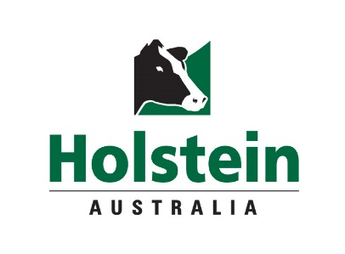

NOMINATION FORM

2017/18 COW OF THE YEAR
MARIO PARK GOLDWYN ALICIA – IMP - ET

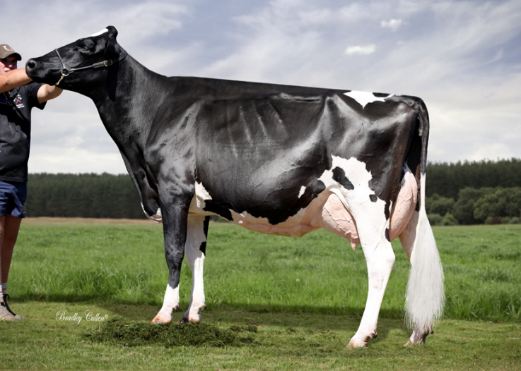

Competition Aim:
To identify and promote the superior “Australian Cow of the Year”

Criteria for Cow of the Year: see competition guidelines for full details
1. The cow must be alive at time of close of entry
2. Promotional photo of entrant to accompany entry.
3. Entries open 1st July 2018 and close 31ST May 2019.
4 The winner will be announced at the National Awards Dinner.
5. Nominations can be received from any Holstein Australia member; even on behalf of others.

NOMINATED COW ……………………………………………………………………….…………………………………………..
DOB ………………………Herdbook No …………………………….... Classification……………………………………...

ABV ………………………………………………………………………………………………………………………………….…

If insufficient space, please send additional information with the nomination form.

NOMINATED ANIMAL’S HISTORY
(e.g. Awards, number of calvings (ET and natural), calving frequency, shows, other special achievements, impact of breed etc.)

………………………………………………………………………………………………………………………………………...……

…………………………………………………………………………………………………………………………………………...…

……………………………………………………………………………………………………………………………………….……..

……………………………………………………………………………………………………………………………………………..

……………………………………………………………………………………………………………………………………….……..

……………………………………………………………………………………………………………………………………………..

PRODUCTION
(Please supply a lactation statement if possible)

………………………………………………………………………………………………………………………..……………………

…………………………………………………………………………………………………………………………………..…………

………………………………………………………………………………………………………………………………………...……

…………………………………………………………………………………………………………………………………………...…

IMPACT OF PROGENY, GRAND PROGENY ON THE BREED
(e.g., Sales, bulls, production, classification, number of progeny classified Ex, VG, GP)

………………………………………………………………………………………………………………………………………..……

………………………………………………………………………………………………………………………………………..……

………………………………………………………………………………………………………………………………………..……

…………………………………………………………………………………………………………………………….…………….…

……………………………………………………………………………………………………………………………….………….…

…………………………………………………………………………………………………………………………………………..…

……………………………………………………………………………………………………………………………………..………

………………………………………………………………………………………………………………………………………..……

……………………………………………………………………………………………………………………………………………

REASONS FOR NOMINATING THIS COW

……………………………………………………………………………………………………………………………….………….…

…………………………………………………………………………………………………………………………………………..…

……………………………………………………………………………………………………………………………………..………

………………………………………………………………………………………………………………………………………..……

……………………………………………………………………………………………………………………………………………...

……………………………………………………………………………………………………………………………………………...

………………………………………………………………………………………………………………………………………..……

………………………………………………………………………………………………………………………………………..……

OTHER COMMENTS:

……………………………………………………………………………………………………………………………………………...

……………………………………………………………………………………………………………………………………………...

……………………………………………………………………………………………………………………………………………...

……………………………………………………………………………………………………………………………………………...

RETURN NOMINATION FORM TO:
Cow of the Year Competition, Holstein Australia, AgriBio 5 Ring Rd Bundoora VIC 3083 or email enquiry@holstein.com.au

For more information contact the office on (03) 9835 7600.
Nominations must be received by 31st May 2019.

Do you want an Award Search done on entrant?
□Yes □ No

Do you want an ad-hoc Award Search done on whole herd?
□Yes □ No

